- A volatile week for gilts demonstrated the importance of the UK government maintaining a credible commitment to fiscal discipline. As things stand, Chancellor Rachel Reeves will likely need to tighten policy by £20bn-£30bn in the Budget this autumn. Most of the savings will come from further tax hikes, with an extension of the freeze on most thresholds the most likely option.
- In remarks in Sintra, external Monetary Policy Committee member Alan Taylor said he thought the neutral interest rate was 2.75%-3%, in a similar ballpark to our estimates. He also backed five 25bp rate cuts in 2025, compared with the four implied by market pricing and in our forecast. We think the data is some way from being weak enough to convince the majority to cut rates faster.
It's been another rollercoaster week for UK government bond yields. In March, the government had announced a series of welfare reforms that it hoped would reduce government spending by around £5bn a year. But the reforms were very unpopular with its own MPs and on Tuesday, the government abandoned the changes. The initial market response was muted, probably because the U-turn had looked the most likely outcome for some time.
But the sell-off gathered momentum on Wednesday afternoon, when Prime Minister Keir Starmer offered what was perceived to be weak backing to Chancellor Rachel Reeves. With Reeves also seen looking upset in the House of Commons, rumours circulated that she could be replaced as Chancellor. Subsequent stronger support from Starmer reversed some of the earlier increase in yields, and by market close on Thursday the spread over US Treasuries was back in line with the average of the past fortnight (Chart 1).
As we argued on Wednesday, the initial sell-off looked overdone. But the episode demonstrated that markets view Reeves as a Chancellor who offers a credible commitment to fiscal discipline, with the subtext being that potential successors may not be as restrained. The experience will also have demonstrated to the government that markets will likely look unfavourably on any further loosening of the fiscal rules, increasing the chances that we see large tax rises in the Budget this autumn.
Chart 1: Markets reacted strongly to rumours that Rachel Reeves might be replaced as Chancellor
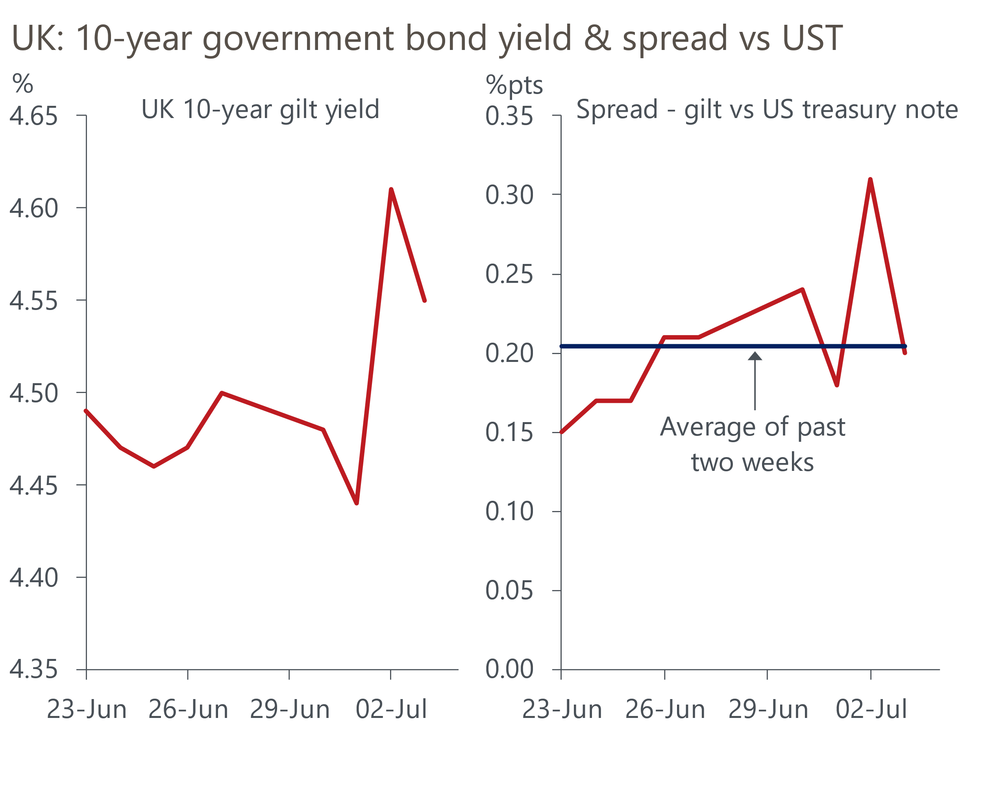
Source: Haver Analytics

Abandoning the welfare reforms will force the government to make £5bn a year worth of savings elsewhere, while its earlier U-turn on winter fuel payments added another £1.2bn. But in reality, the impact of these policy changes is likely to pale in comparison to the increase in borrowing that will result from the Office for Budget Responsibility downgrading its growth forecasts.
We had thought this week's Forecast Evaluation Report might send a clear signal that the OBR was preparing to cut its forecasts. In the event, the messaging was more subtle. But the combination of the OBR admitting it has systematically overestimated growth and underestimated borrowing over the medium-term, and the fact that its current forecasts for potential output growth are well above the consensus, suggests that a downgrade is likely. In a recent note, we estimated that the OBR could cut its projection for potential output in 2029/30 by 1%-1.4%, which would increase its borrowing forecast by £12bn-£20bn.
Adding in the impact of unfavourable movements in financial market pricing, the government will likely need to tighten policy by £20bn-£30bn in the Budget just to comply with the fiscal rules with the same wafer-thin headroom that it allowed in the last two fiscal events. And that's before allowing for any increase in defence spending following last week's NATO announcement. It seems very unlikely that the government will be able to fill this hole without going back on its 2024 election manifesto commitments not to increase national insurance, the basic, higher, or additional rates of income tax, and VAT. At this point, the most likely option appears to be extending the freeze on most personal tax allowances and thresholds for another two years beyond the current endpoint of 2027/28.
Further tightening of fiscal policy is one factor that could cause the Bank of England to speed up its loosening of monetary policy. Alan Taylor, one of the more dovish members of the Monetary Policy Committee, participated in a panel session at the ECB Forum on Central Banking in Sintra this week, in which he advocated greater transparency from policymakers, particularly around their expectations for the path of Bank Rate. His comments mainly centred on the neutral rate, which he estimated to be 2.75%-3%, in a similar ballpark to our own estimate. But he also said that he thinks the economy needs five 25bps rate cuts in 2025, rather than the four implied by market pricing and in our forecast.
This week's data wasn't weak enough to offer much backing for Taylor's view. The BoE's Decision Maker Panel showed that price and wage expectations continued to drift downwards in the three months to June (Chart 2). The final S&P Global surveys for June told a similar story of gently easing price pressures, while a stronger services outturn drove the composite PMI to its highest level since September. And the BoE's Money & Credit release for May reported a pickup in mortgage approvals, as stamp duty distortions began to fade, and stronger gross unsecured lending. While activity remains relatively sluggish, we still appear to be some way away from a situation that might encourage the majority of the MPC to back faster rate cuts.
Chart 2: Firms' price and wage expectations continue to slowly drift downwards
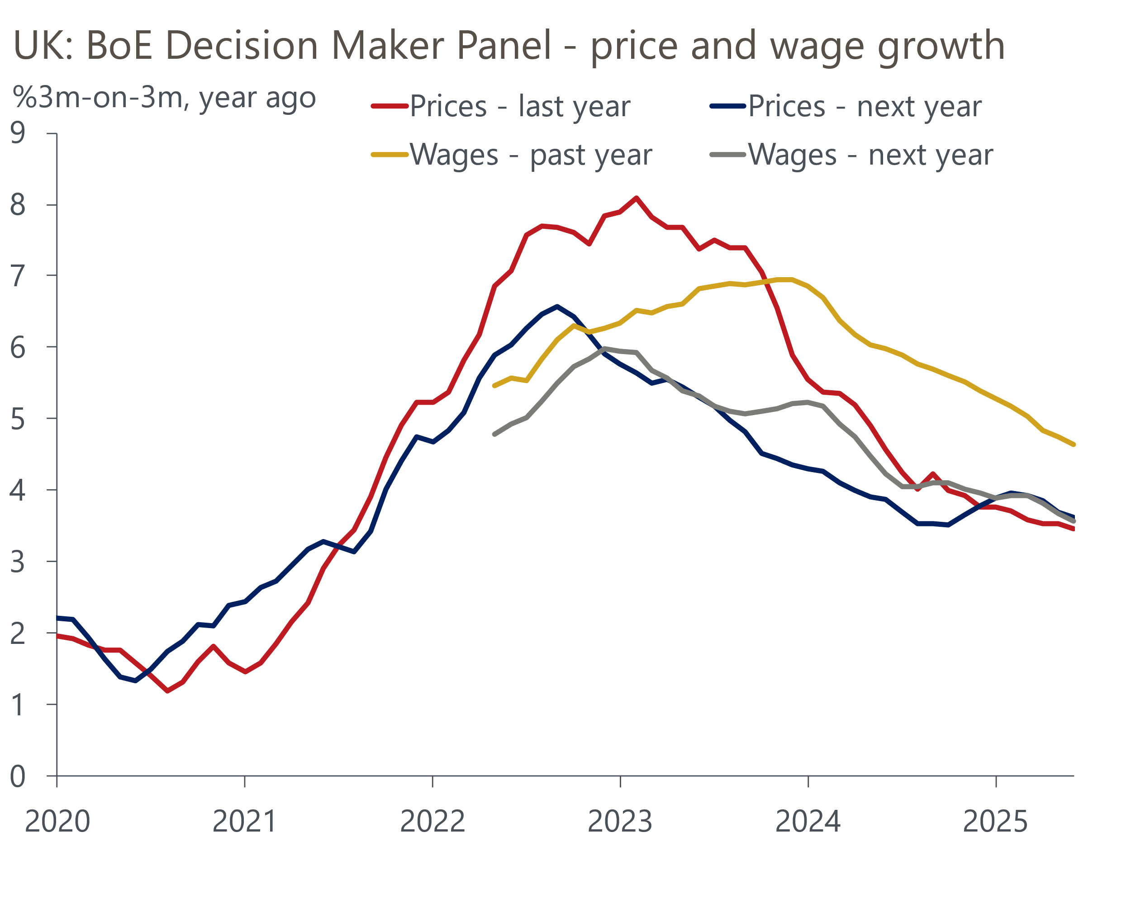
Source: Bank of England Decision Maker Panel.

The week ahead
Next week's only major release is the GDP data for May. After chunky rises in three of the previous four months, GDP fell by 0.3% m/m in April. A sharp fall in retail sales in May means that the distribution sector is likely to have been a large drag on GDP that month. But we see scope for a rebound in output in the large professional services sector, which had a particularly bad April. On balance, we forecast that GDP was flat in May.
Table 1: Week ahead calendar
Date | Events | Period | Measure | Unit | Previous | Forecast
Jul 11 | GDP | May | m/m | % | -0.3 | 0.0
Jul 11 | GDP | May | 3m/3m | % | 0.7 | 0.4
Jul 11 | Index of services | May | m/m | % | -0.4 | 0.1
Jul 11 | Index of services | May | 3m/3m | % | 0.6 | 0.4
Jul 11 | Manufacturing output | May | m/m | % | -0.9 | -0.4
Jul 11 | Manufacturing output | May | y/y | % | 0.4 | 0.7
Jul 11 | Industrial production | May | m/m | % | -0.6 | -0.3
Jul 11 | Industrial production | May | y/y | % | -0.3 | 0.3
Jul 11 | Construction output | May | m/m | % | 0.9 | -0.7
Jul 11 | Construction output | May | y/y | % | 3.3 | 1.2
Jul 11 | UK trade | May | Trade balance | £bn | -7.0 | -4.0
Jul 11 | UK trade | May | Visible balance | £bn | -23.2 | -20.2
Source: Oxford Economics

Key forecasts
Table 2: UK forecast overview
(Annual percentage changes unless specified)
 | 2023 | 2024 | 2025 | 2026 | 2027 | 2028
GDP | 0.4 | 1.1 | 1.1 | 0.9 | 1.3 | 1.8
Private consumption | 0.5 | 0.6 | 1.0 | 1.2 | 1.3 | 1.7
Fixed investment | 0.3 | 1.5 | 2.0 | 0.6 | 1.6 | 2.0
Government consumption | 1.6 | 3.0 | 1.5 | 1.7 | 1.6 | 1.7
Exports of goods and services | -0.4 | -1.2 | 1.0 | -0.7 | 1.2 | 1.4
Imports of goods and services | -1.2 | 2.7 | 2.5 | -1.2 | 1.1 | 1.4
Industrial Production | -0.8 | -1.2 | 0.0 | -0.3 | 0.8 | 1.2
Consumer prices | 7.3 | 2.5 | 3.2 | 2.5 | 2.4 | 2.1
Unemployment rate (%) | 4.1 | 4.3 | 4.7 | 4.9 | 4.8 | 4.5
Current a/c balance (% of GDP) | -3.5 | -2.7 | -3.1 | -2.8 | -2.7 | -2.6
Government balance (% of GDP) | 5.2 | 5.1 | 4.3 | 3.6 | 2.9 | 2.6
Central bank policy rate (%, EOP) | 5.25 | 4.75 | 3.75 | 3.00 | 2.50 | 2.50
10yr govt. bond yield (%, EOP) | 3.54 | 4.57 | 4.50 | 3.96 | 3.44 | 3.35
Exchange rate (US$ per £, EOP) | 1.27 | 1.25 | 1.35 | 1.35 | 1.35 | 1.35
Exchange rate (euro per £, EOP) | 1.15 | 1.21 | 1.19 | 1.19 | 1.19 | 1.19
Source: Oxford Economics
Table 3: Quarterly forecasts for the UK
 | 2025 |  |  |  | 2026
 | Q1 | Q2 | Q3 | Q4 | Q1 | Q2 | Q3 | Q4
GDP (% year) | 1.3 | 0.9 | 1.1 | 1.2 | 0.7 | 0.8 | 0.9 | 1.0
CPI inflation (% year) | 2.8 | 3.4 | 3.5 | 3.2 | 3.0 | 2.2 | 2.4 | 2.5
Bank Rate (%, EOP) | 4.50 | 4.25 | 4.00 | 3.75 | 3.50 | 3.25 | 3.25 | 3.00
10yr gilt yield (%, EOP) | 4.70 | 4.70 | 4.61 | 4.50 | 4.37 | 4.24 | 4.10 | 3.96
US$ per £ (EOP) | 1.29 | 1.35 | 1.35 | 1.35 | 1.35 | 1.35 | 1.35 | 1.35
Euro per £ (EOP) | 1.20 | 1.19 | 1.19 | 1.19 | 1.19 | 1.19 | 1.19 | 1.19
Source: Oxford Economics

Latest Country Economic Forecast:
June 17, 2025

Recent publications

Data Insights
PMIs suggest growth was relatively soft in Q2
Manufacturing sector struggles on
Mortgage activity recovers as stamp duty distortions start to fade
Headwinds to growth are intensifying
Flash PMIs report continued weak activity growth

Research Briefings
How the sectoral mix of jobs is changing and what it means
MPC’s dovish hold boosts the chances of an August cut
MPC Preview – Divided committee to pause in June
Unconvincing spending review is another fiscal stopgap
Tough fiscal choices looming in the Autumn

Contacts

Oxford Economics' UK team
- Andrew Goodwin - Chief UK Economist - agoodwin@oxfordeconomics.com
- Edward Allenby - UK Economist - eallenby@oxfordeconomics.com

